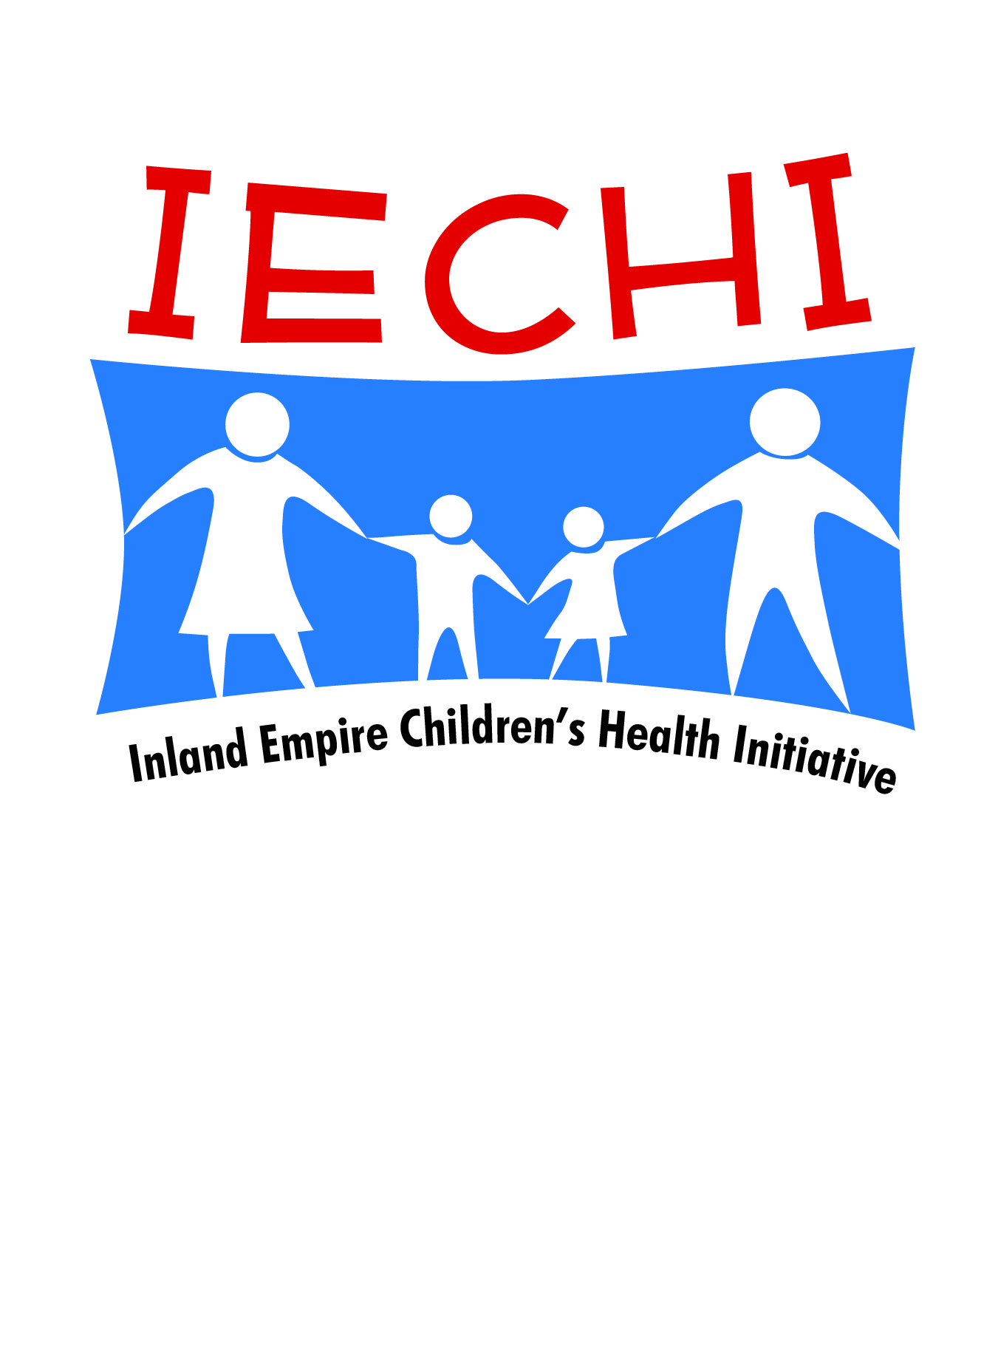
IE-CHI CHIPRA Outreach/Enrollment
Recap meeting-Riverside County May 12, 2014
In attendance: Fred Deharo, Lenny Pepper (Borrgo), Yvette (RHA), Edith (CoCa),
Sendy Sanchez (SBCCCA). Marci Aguirre (IEHP) Luanne Loza (IEHP)
Purpose; To evaluate the strategies used in the first CoCa open Enrollment period in Riverside County
in relation to IE-CHI Health Team approach to Medi-cal and CoCa outreach/education and enrollment
Effective Strategies:
- Collaboration trough IE-CHI and other groups (Coachella partnership)
- Clinic on site enrollment
- School district enrollment (on site/back to school nights, health fairs)
- We Connect Fair
- Phone banks
Least Effective
- Big events
- Wholesale
Next steps:
- Groups to engage: College campuses Leaders –to reach young adults
Faith organizations: Catholic Diocese, TURN, ICUC)
Vocational Schools
- Needs: More Bi-lingual Counselors (CECs)
Social media marketing especially to young adults (Twitter, etc)
Training for CEC/CEA on Medi-cal , terminology, examples
- Engaging Latino population: More Bi-lingual Counselors
Better Culturally sensitive collateral materials
Addressing men of households/fathers
Allow more time for review of budget/plans by families
Allow time for more contacts (“touchs”)
Cultivate popular locations (Supermarkets/swap meets)
- IE-CHI support suggestions: Continue to post events, etc on website master calendar
Coordinate media campaign
Support material development
Coordinate Regular meetings: (Monthly)

